**Q1. Why java is called multi-threaded language?**

Java is a *multi-threaded programming language* which means we can develop multi-threaded program using Java. A multi-threaded program contains two or more parts that can run concurrently and each part can handle a different task at the same time making optimal use of the available resources specially when your computer has multiple CPUs.

By definition, multitasking is when multiple processes share common processing resources such as a CPU. Multi-threading extends the idea of multitasking into applications where you can subdivide specific operations within a single application into individual threads. Each of the threads can run in parallel. The OS divides processing time not only among different applications, but also among each thread within an application.

Multi-threading enables you to write in a way where multiple activities can proceed concurrently in the same program.

**Life Cycle of a Thread**

A thread goes through various stages in its life cycle. For example, a thread is born, started, runs, and then dies. The following diagram shows the complete life cycle of a thread.

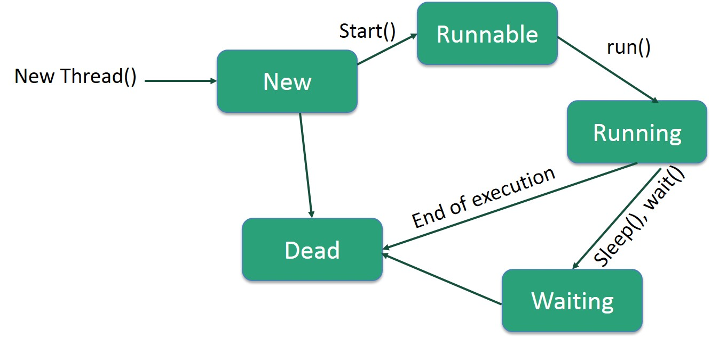

**Following are the stages of the life cycle −**

**New** − A new thread begins its life cycle in the new state. It remains in this state until the program starts the thread. It is also referred to as a **born thread**.

**Runnable** − After a newly born thread is started, the thread becomes runnable. A thread in this state is considered to be executing its task.

**Waiting** − Sometimes, a thread transitions to the waiting state while the thread waits for another thread to perform a task. A thread transitions back to the runnable state only when another thread signals the waiting thread to continue executing.

**Timed Waiting** − A runnable thread can enter the timed waiting state for a specified interval of time. A thread in this state transitions back to the runnable state when that time interval expires or when the event it is waiting for occurs.

**Terminated (Dead)** − A runnable thread enters the terminated state when it completes its task or otherwise terminates.

# Daemon Thread in Java

**Daemon thread in java** is a service provider thread that provides services to the user thread. Its life depend on the mercy of user threads i.e. when all the user threads dies, JVM terminates this thread automatically.

There are many java daemon threads running automatically e.g. gc, finalizer etc.

Note:- You can see all the detail by typing the jconsole in the command prompt. The jconsole tool provides information about the loaded classes, memory usage, running threads etc.

JVM

Finalizer

GC

Daemon Thread

Main Thread

## Points to remember for Daemon Thread in Java

1. It provides services to user threads for background supporting tasks. It has no role in life than to serve user threads.
2. Its life depends on user threads.
3. It is a low priority thread.

### Why JVM terminates the daemon thread if there is no user thread?

The sole purpose of the daemon thread is that it provides services to user thread for background supporting task. If there is no user thread, why should JVM keep running this thread. That is why JVM terminates the daemon thread if there is no user thread.

### Methods for Java Daemon thread by Thread class

The java.lang.Thread class provides two methods for java daemon thread.

|  |  |
| --- | --- |
| **Method** | **Description** |
| public void setDaemon(boolean status) | is used to mark the current thread as daemon thread or user thread. |
| public boolean isDaemon() | is used to check that current is daemon. |